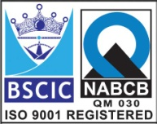****

**“EASCO” Double Flange Center Disc Butterfly Valve Lever Operated**

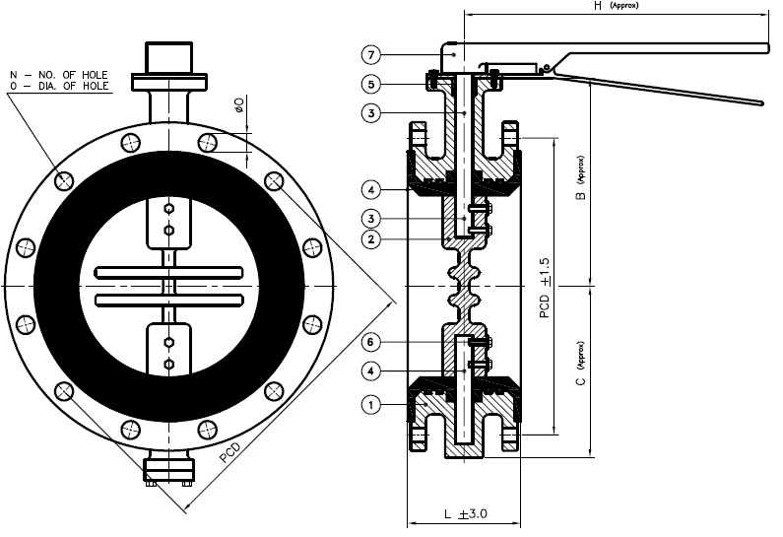

**Features: -**

* Zero Leakage
* Leak Tight Shut Off
* Lower Torque
* Smooth Operation & Installation
* Long Life
* Available in PN10 / PN16

**Testing Standard: - BS 6755**

|  |  |  |
| --- | --- | --- |
| Test Pressure in PSIG | | |
| Test | Hydrostatic | Hydrostatic  PN 16 |
| Pr. Rating | PN 10 |
| Body | 340 | 425 |
| Seat | 230 | 300 |

**Part List: - Standard Dimension (150#): -**

|  |  |  |  |  |  |  |  |  |  |  |  |  |  |  |  |  |  |
| --- | --- | --- | --- | --- | --- | --- | --- | --- | --- | --- | --- | --- | --- | --- | --- | --- | --- |
| **No.** | **Part Name** | **Materials** |  | **Size** | **50** | **65** | **80** | | **100** | **125** | **150** | **200** |  |  | | |  |
| 01 | Body | IS 210 Gr. FG 200 / Ductile Iron  A 216 Gr. WCB / CF8 / CF8M |  | L | 108 | 112 | 114 | | 127 | 140 | 140 | 152 |  |  | | |  |
|  | B | 125 | 135 | 155 | | 160 | 180 | 210 | 250 |  |  | | |  |
| 02 | Disc | IS 210 Gr. FG 200 / Ductile Iron  A 216 Gr. WCB / CF8 / CF8M |  | C | 85 | 95 | 102 | | 114 | 134 | 147 | 175 |  |  | | |  |
|  | H | 180 | 180 | 215 | | 215 | 265 | 265 | 325 |  |  | | |  |
| 03 | Stem | AISI 410/304/316 |  | PCD | 121 | 140 | 152 | | 190 | 216 | 241 | 298 |  |  | | |  |
| 04 | Body Seat (Liner) | Neoprene / EPDM / Nitrile / Silicon / Viton / Other Request |  | N | 4 | 4 | 4 | | 8 | 8 | 8 | 8 |  |  | | |  |
|  | O | 19 | 19 | 19 | | 19 | 22 | 22 | 22 |  |  | | |  |
| 05 | Gland Seal | Neoprene / EPDM / Nitrile / Silicon / Viton |  | ISO 5211 Flange | F05 | F05 | F05 | | F05 | F05 | F05 | F07 |  |  | | |  |
| 06 | Disc Lock Pin | CS / SS |  |  | | |  |  |  |  |  |  |  |  | |
| 07 | Hand Lever | CS / SS |  |  | | |  |  |  |  |  |  |  |  | |
| 08 | Throttling Plate | CS / SS |  |  | | |  |  |  |  |  |  |  |  | |
| 08 | Fasteners | CS / SS |  |  | | |  |  |  |  |  |  |  |  | |
|  | | | | | | | | | | | | | | |

**Due to continuous development Program, the design & data given in this leaflet are subject to change without prior notice.**

**ANITA ENGINEERING WORKS**



58-59, Narayan Estate, Opp. Shree Ram Estate, Nr. CMC Ltd. Odhav, Ahmedabad-382415, Gujarat, India

Phone: +91 79 22974101, Fax: +91 79 22875014

Email: eascovalves@gmail.com, eascovalves@yahoo.com, Web: [www.eascovalve.com](http://www.eascovalve.com)